Therese Evelyn Marie Thomas Greene
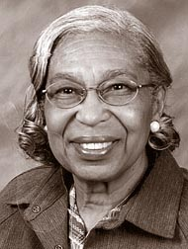
Therese Thomas was born January 12, 1930 in Washington D.C. Therese grew up on P Street in the North West section of Washington. She graduated from Dunbar High school in 1947 and completed Miner teachers college in 1952, with a teaching degree. Therese and Carl Greene met when Carl was earning his engineering degree and they married in 1952. Therese worked as a teacher in the D.C schools while Carl was overseas in the U.S Air Force. Therese and Carl Sr. relocated to Wright Patterson Air Force Base in 1953 and started a family with Carl Jr. and Cecilia. The Greene family moved to Yellow Springs in 1958 and Gerald was born in 1959. Therese had a par time job at Goes Playschool from 1965 through 1970. Her husband, Carl Sr. passed away in 1969. Therese restarted her teaching career at Mills Lawn School in 1970 teaching special elementary school. She attended Wright State University to earn her master’s degree in Special Education in 1977. Therese retired from Mills Lawn School after 20 years. In her later years Therese traveled to many places like North Africa, Europe, Caribbean cruises, Mediterranean cruises, West Africa, South African and England.
Therese was part of the Alpha Kappa Alpha Sorority and a member of the National Honor Society. Therese Evelyn Marie Thomas passed away when she was 88 years old in 2018.

