Doris Frances Blake
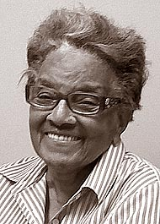
Doris Blake was born on January 28, 1920 in Philadelphia to James Arnold and Jesse Vine. She spent her early years in Pennsylvania. In 1947, Doris married Walker Blake II. He was a young army Lieutenant who promised to show her the world. They immediately moved post-WWII Philippines. They had five children, nine grandchildren and six great-grandchildren.
Doris Blake passed away in April 21, 2018 98 years old. Mrs. Blake was preceded in death by her husband and eldest son, Walker M. Blake. She is survived by Cassandra Blake Zarkades and husband, Nick; Aurelia Blake; Philip Blake and wife Janice; James Blake and wife, Vanetta; her grandchildren Nicole Blake and Darby Blake, Talia Blake, Matthew Wallace and Hyacinth Wallace, Zoe and Blake Zarkades, James Blake II and Walker M. Blake IV; and myriad sons and daughters of Yellow Springs and the Yellow Springs Baha’I community.
Adapted from Yellow Springs News Obituary, April 26, 2018

