Mary Catherine Mason
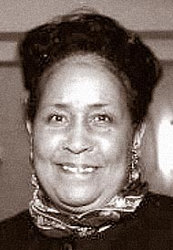
Mary was born in Springfield, Ohio and her parents were Samuel Neal and Rachel Buford. She lived in Springfield for many years until 1960, when she moved to Yellow Springs. When she was in Springfield, she worked at St. Bernard Catholic Church then worked in Wittenberg University as a supervisor. In 1964 her husband and she opened Gabby’s Pit BBQ. She had a long battle with Alzheimer´s disease. Mary Mason passed away when she was 92 years old in Austin, Texas on January 2018.

