Dawn Page
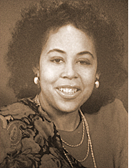
Dawn Page was born on July 22, 1963 at Fort Benning´s Martin Army Hospital in Columbus, Georgia. Her parents were Ervin and Datie Page. Born in to a military family they traveled every two years following Dawn´s father to his new assignment. Dawn had two younger brothers, Martin and Kenneth and a sister, Carol. The Page family moved to Yellow Springs in the summer of 1974 where Dawn attended Yellow Springs public schools. After attending Mills Lawn Elementary School, she then attended Arthur E. Morgan Middle School and she graduated from Yellow Springs High school in 1982. Dawn was an excellent student and runner. She set track records in the quarter mile from middle school through high school, and she also played the clarinet. Dawn enjoyed singing with a school, college and church choirs. At Central Chapel A.M.E. church, Dawn and her siblings joined the youth choirs. After finishing high school, Dawn received partial scholarships and she attended Central State University in Wilberforce and pursue her plan to become a Special Education teacher.
In 1986, during Dawn’s final year of college, the tuberous sclerosis, with her since birth, caused a brain tumor that required her to go through surgery. The tumor and surgery affected Dawn´s short- term memory, medically derailing her dream of helping children with challenges. Dawn passed away on July 29, 2018. She overcame incredible adversity, where her dreams were derailed by tragedy, and yet she became an inspiration, facing all life’s travails with a faithful grace.
Adapter from Yellow Springs News obituary, August 9, 2018

