Barrett Eugene Blackwell
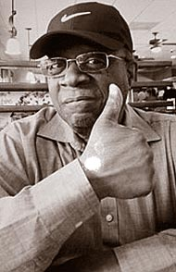
Barrett Eugene Blackwell was a long time resident of Georgia originally from Yellow Springs, Ohio. In his early years he was an excellent athlete in track and field, swimming and weightlifting. He attended Bowling Green State University and obtained his degree in Biology. He obtained his master’s degree in Counseling from Wright State University. Mr. Blackwell had a long, varied and successful career before retiring in 2014. Mr. Blackwell was a lifelong entrepreneur and family man.
Barrett was a family man and always placed his family before him. Barrett Blackwell passed away when he was 66 years old on January, 2018. He was survived by his wife, Hazel (Sacares); sons Foluke, Hashim and Barrett isidro; and daughter Abigail. He is survived by his mother, Anna Clara (Oliver Hagans) Gee Blackwell- Hagans, of Springfield, Ohio; brother Harold B. (Cindy) Blackwell Jr., of South Pasadena, Calif.; sisters Nisa D. Blackwell-Turner and Valerie A. (Buck Truitt) Blackwell- Truitt, of Yellow Springs; and Cynthia L. Blackwell of Framingham , Mass. Mr. Blackwell was also survived by his nephews , Elliott Blackwell, Steven Blackwell, Adam J. Truitt, A. Justin Truit, and Kyle M. Truitt, along with a host of cousins, aunts and uncles.
Adapted from Yellow Springs News obituary, February 1, 2018

