Mary Julia (Adams) Alexander
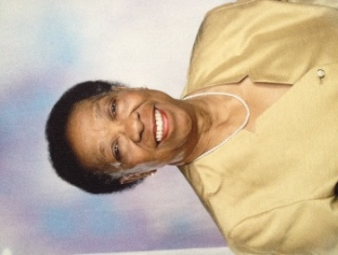

Mary Julia (Adams) Alexander was born in Xenia, Ohio on 25 April 1937. Affectionately known as Mary Julia to her family, she was one of four children born to Ivanora and Richard Adams. Raised in Xenia’s East End, Mary graduated from East High School in 1955.

Following high school graduation Mary attended Bowling Green State University, returning to Xenia after two years of study. It was in Xenia that Mary met, and later married, William Alexander, a Central State graduate from Louisville, Kentucky.

Being attracted to the village’s high quality school system and diverse community, the young couple moved to Yellow Springs in 1963 to raise their family - Noreda (Class of 1976), William (Class of 1979), Norman (Class of 1981), and Ivanora (Class of1985).

During the early years in Yellow Springs Mary was a stay-at-home mom. As the children grew and became involved in various activities, Mary grew with them, serving as a Den Mother for the local Boy Scout Troop, assisting with various girl scouting adventures, horseback riding events, stamp collecting, music lessons, and more.

In the 1970’s, Mary’s entrepreneurial spirit resulted in the birth of MJ’s Typing Service. This home business provided the Yellow Springs community and surrounding areas with a professional publishing service. During this time Mary developed many relationships as she had a wide array of regular clients - students, a horticulturist, an attorney, a health organization, an environmentalist, a newspaper editor, psychologists, a retired college professor, realtors, universities, and public and private schools. It was during this time Mary was also actively engaged in the community, working at the Yellow Springs Library as library assistant; in the Yellow Springs school system as assistant to the school treasurer; and as substitute secretary for Mills Lawn, Morgan Middle, Yellow Springs High School, and in the school board office. In 1985, Mary expanded MJ’s typing service and began traveling to various business offices in the area to provide assistance with word processing and typing needs.

In 1987, Mary was hired by Dr. Gary Klein of Klein Associates (Yellow Springs) where she eventually became the office supervisor. In 1994 Mary returned to college full time. In 1996 she achieved a lifetime goal when she graduated from Antioch University’s McGregor School with a Bachelor of Arts in Business Management.
Mary loved Yellow Springs, and at an age where most people would have taken advantage of retirement, Mary chose to give back to the community that had given so much to her family. This was evidenced in 2003 when she completed the Yellow Springs Leadership Institute, and was appointed and later elected to the Yellow Springs Village Council. She was committed to, and faithfully represented, community interests. Mary was a liaison to the Yellow Springs Library Commission, the Cable Panel, and the Planning and Coordinating Commission of Greene County. She was instrumental in revamping the Library Commission and writing revisions to its responsibilities; recognizing the many village volunteers at a recognition program; and was involved in the origination and approval of a Village Council ordinance giving a thoroughfare the memorial name of James A. McKee Way.

Mary’s reach into the community was further extended through her volunteer experiences with the Yellow Springs Men’s Group -- researching the cost of living in Yellow Springs; assisting with the publication of “Celebrating Women: The Women’s Park of Yellow Springs”; as secretary of the Yellow Springs Library Association, Membership Chairperson, and a member of the Art Committee; at Friends Care Center as the medical records clerk; and at Mills Lawn Elementary School as a third grade reading partner.

Mary had a social life in Yellow Springs that included her love for entertaining. She opened her home to many, hosting friends and family.

Crocheting, playing bridge, genealogy research, and staying connected to her four grandchildren (Michael, Inda, Hunter, and William) were her passions. In addition to her grandchildren, a tremendous source of pride for Mary was that all four of their children graduated from Yellow Springs High School and went on to obtain Bachelor of Science (BS) degrees in science and engineering.

Mary was past member of Zion Baptist Church (Xenia), First Baptist Church (Yellow Springs), Second Missionary Baptist Church (Springfield), and Broadway Baptist Church (Louisville, KY) – actively involved in each. She was also an active member of Delta Sigma Theta Sorority, Incorporated (Wilberforce Alumnae Chapter, Spring 1998), a public service organization; the Wilberforce Chapter of The Moles, a family oriented social group; and the Twentieth Century Club of Xenia, a literary organization.
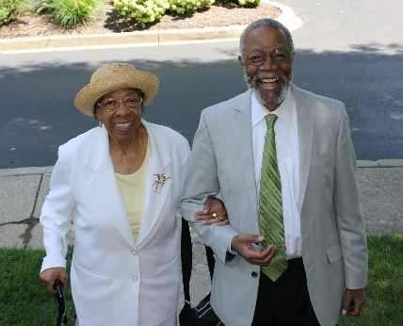
In 2008, Mary and her husband Bill relocated to Louisville, Kentucky – Bill’s childhood home. There she continued doing what she loved starting a bridge club in their new home; supporting the community service and scholarship related functions of her sorority, Delta Sigma Theta, Incorporated; enjoying trips with the Louisville Moles; and relishing visits with and from her children, grandchildren, family members, and friends. Mary was active until her death in 2014. She is buried, along with her husband, at the Kentucky Veterans Cemetery in Fort Knox, Kentucky.

Noreda Alexander

